**SUMMING OF EVEN NUMBERS**:

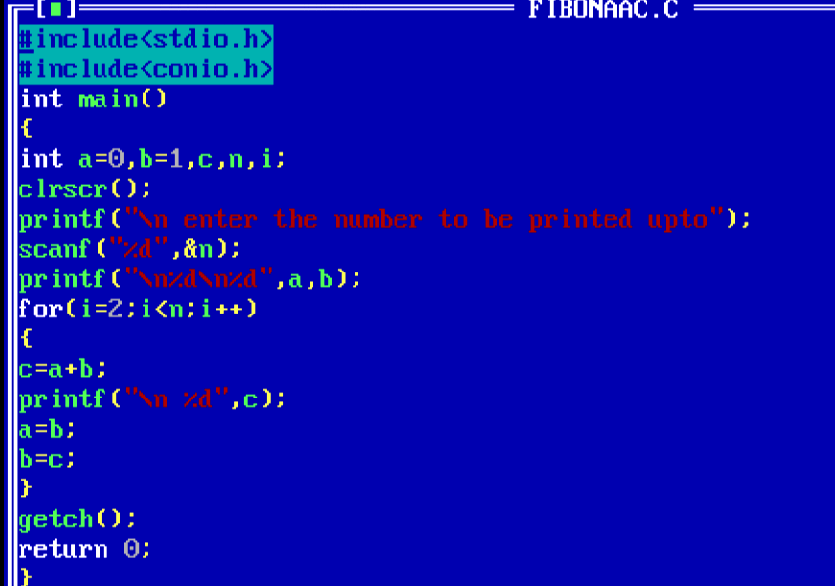

**OUTPUT:**

